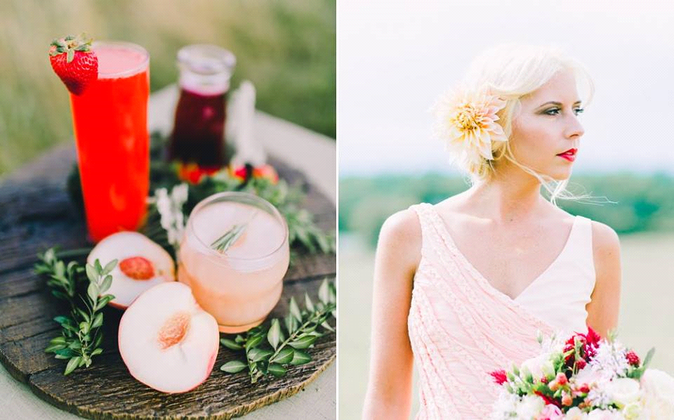

612 Preston Avenue
Charlottesville, Virginia 22903
434.979.5556
Email Contact: Jessica@moxiehairlounge.com
Check our our website for further information: http://www.moxiehairlounge.com

2024 PRICES AND POLICIES
Thank you for considering Moxie Hair & Body Lounge for your bridal services. Below is a list of our prices and company policies regarding Moxie’s bridal services. If you have any questions or would like to schedule any appointments, please contact Jessica, our Bridal Consultant at bridal@moxiehairlounge.com or (434) 979-5556.

Please do not ask your bridal consultant to provide you a quote before sending the bridal information sheet back to us. Thank you in advance!
PRICES: (THESE ARE STARTING PRICES)
In house, normal business hours Per Person:
Service | Bridal Team
Bride – Special Event Style | $170+
Bride - Trial Run, Special Event Style | $120+
Updo, Half up – Bridal Party | $120+
Blow Out & Style – Bridal Party | $50
Make-Up – Bride | $140+
Make-Up – Trial Run | $100+
Make-Up – Bridal Party | $120+
Make-Up – Eyes Only (Bridal Party Only) | $55
False Eyelashes – Day Use | $35

These Prices are subject to change based on the level of the Stylist and Makeup Artist.
If you have questions about our stylist levels or would like to request a certain stylist level, please let your coordinator know ahead of time.

Trial Run: We require a trial run for the bride’s hair service. A make-up trial run is at the bride’s discretion. (but is highly recommended) If any other member of the bridal party would like a trial run, it too will be billed as a separate service. They are only available in the salon and we prefer for these to be scheduled no earlier than 1-2 months prior to the wedding date.
You are responsible for paying the trial fee the day of the trial appointment. We do not accept early payments for your trial, and we do not include the trial cost in the wedding day contract.
Gratuity: There is a 20% Auto Gratuity applied to all bridal (event) services. In house or on site. These prices listed do NOT include gratuity
On Site/Sunday/Holiday Bridal Services Per Person:

Service | Bride | Bridal Party
Bride – Special Event Style | $250 | -
Updo/Half up | N/A | $185+
Blow Out & Style | N/A | $95+
Make-Up | $175 | $140+
Make-Up – Eyes Only | N/A | $100+
False Eyelashes – Day Use | $35 | $35

Fees: There is a Travel Fee based off of location of services and number of stylists to provide services. The travel fee starts at $175.00. This includes anything within a 20-mile radius.

Sunday & Holiday Weekends: For Sundays and holiday weddings, please refer to the on-site pricing table (even if you are coming to the salon for your services). If you are interested in our team coming both on-site AND it’s a Sunday wedding, the travel fee will be increased. Please get with your coordinator about that extra fee. Our Bridal suite is also available on Sundays for an extra fee. Please let your coordinator know if you’re interested.

Service Minimums: There is a minimum of $800 contract for all on-site services. The contract must meet the $800 requirement before the travel fee is included.

Contract: Please be sure to make all your adjustments for downgrades and upgrades 30 days prior to the wedding. We do not send out an updated contract after every change that is made.

Deposit- This fee is applied to the client’s account to hold the wedding date and will be used towards your day of services. You will not receive a final invoice until after all the contracted services have been completed and your credit card has been charged for the remaining balance.

*Starting prices are subject to change until the contract is locked in*

Policies

Trial Run:

- For the bride, Moxie requires a trial run with the stylist. This stylist is also who will be doing the bride’s hair the day of. We recommend receiving your trial run no more than two months prior to the wedding. A make-up trial run is at the discretion of the bride but is strongly recommended. Please see page one for pricing.

- It is highly recommended that you bring your veil or hair piece and a picture of your wedding dress to your trial.
- Please bring in any photos of hair styles and makeup that you like/dislike.
- If you are having portraits done on the same day as your trial, please be sure to mention that when scheduling your trial, so that we allow extra time for a final style. Please note: We cannot accommodate extra time for a final style without some sort of notice ahead of time.

Wedding Day:

- We understand the importance of running on time, and to achieve this, we request that everyone arrive at the contracted location together at the agreed upon start time. This allows our team to easily flow from one client to the next without large gaps in between.

- For on-site services, those receiving a Blow Out and Style should arrive with freshly washed hair. Those receiving up-dos should arrive with clean, dry hair. (No styling products)

- Those receiving makeup applications should arrive with just a clean & moisturized face.

- On the day of the wedding, everyone receiving an updo should arrive in a button-down shirt to be sure not to disturb your hairstyle and/or makeup when changing clothes.

- Failure to come with clean hair may lead to an increase in price if your stylist must prep the hair first.

- An up-do is defined by any style that involves pinning, this does include half up styles.
- Please make sure your party is aware that if anyone decides to upgrade their service on the day of, the pricing will be reflected on the ending total amount due. For example, going from a blowout/style to a Updo/Half updo would result in an upcharge.
- For those receiving full make-up application, we provide several choices in lip wear. However, if you have a preferred product, please bring that with you. All other makeup products will be provided by your stylist. Please let our coordinator know if you have any skin allergies that we should be aware of.

Scheduling Your Bridal Services:

- Please return the Moxie Bridal Information Sheet with as accurate details as possible. This sheet acts as a cover sheet to the actual contract if you choose to move forward with our team. The bridal consultants will make the day of schedule and complete the contract only after receiving the information sheet.

- Our Bridal consultants have a positive working relationship with many local Bridal and Event Planners. If you are using a planner, your consultant will work with them directly as necessary to schedule and confirm appointments.

Hair Styling Choices:
- An Updo is described as any style where pinning is needed to hold the hair, this DOES include half up styles as well.
- Blowouts – All of our blowouts come with a shampoo service if you are having your parties’ services done at Moxie Hair Lounge. If our team is traveling on site, we ask that your party arrive with damp, not soaked, hair.
- Please note: The bride’s hair services are charged the same amount for an updo OR a blowout.

Deposit:

- You may pay the deposit by returning the Credit Card Authorization Form or by contacting Jessica or Mariam at 434.979.5556.

- We require a deposit of 50% for all services scheduled and a credit card number on file.
Please note: Your wedding date is not held without a paid deposit!

- The deposit due date will be listed on your contract. There are no exceptions to this date.
- Should you make initial contact with Moxie within 15 days of your wedding date, your deposit will be due immediately to schedule any appointments.
- Payment for the remainder of the services will be charged on the day of the wedding to the card you provided for your deposit. No split payments will be accepted.
- If you need to change your credit card information for the final payment, please contact your coordinator as soon as possible.
- If it is an on-site wedding, and you would like us to send you an invoice of your services, please let your coordinator know the best e-mail to use.

Cancellations and Schedule Changes:
- Moxie requires a 60 day notice for the cancellation of an entire wedding party contract. This will result in a non-refundable deposit.

- Moxie requires a 15 day notice for any individual bridal party member cancellations. Failure to do so will result in being charged the entire price of the canceled appointment on the wedding day.
- Changes to the schedule must be made at least 15 days prior to the wedding day or the greater service price will prevail. Changes to the original scheduled contract will be subject to availability.
- Any additional services will be billed as determined by the stylist and contracted prices. This may include if a client asks a stylist to perform more than one style or requires more than allotted time.
- Any alteration to the original service will be billed as determined by the stylist.

Safe Working Environment:
Moxie Hair & Body Lounge continues to always maintain a safe and clean working environment consistent with current health and safety recommendations. If anyone in the party has tested positive for Covid-19 recently or is showing any symptoms, all stylists of Moxie Hair and Body Lounge reserve the right to not perform any services.

